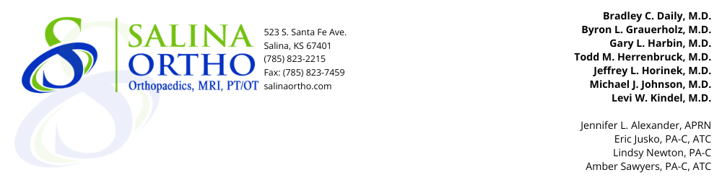

Todd M. Herrenbruck M.D.
TOTAL SHOULDER REPLACEMENT INFORMATION

- Your lab and all testing will be done ahead of time in Salina, if possible.
- Follow instructions given by the office regarding stopping your blood thinning medications.
- Do not eat or drink anything after midnight prior to surgery.
- Please take a bath or shower the morning of surgery.
- Please bring any necessary medical equipment with you (polar pack, brace, CPAP etc)
- Bring good walking shoes.
- Wear comfortable, loose-fitting clothes and bring personal hygiene items with you.
- Bring a list of your medications to the hospital.
- You will be admitted to the hospital 2 hours before surgery. Anesthesia will visit with you at this time. The surgery will last about 1 hour.
- Preventative measures to avoid complications include:
- IV antibiotics to prevent infection, skin sores, regular dental visits.
- Clean air flow room to prevent infection.
- Deep vein thrombosis prevention with Aspirin 325mg daily for 6 weeks.
- Early walking and foot compression pumps in the hospital. No flying for approximately 6 weeks.
- Your hospital stay will be 1-2 days. You will then go home or be transferred to Rehab for 4-5 days if warranted.
- You will have staples for 10-14 days. Showering is permissible. An appointment will be given to return to our office for staple removal and surgical bandage removal.
- Occupational therapy will assist you with exercises and rehabilitation at the Surgical Hospital and outpatient physical therapy will be ordered at your 2-week post-op appointment.
- Pain pills will be provided for one month. You may need to take a stool softener with pain medications.
- You may need to purchase a shower chair, grab bars, or other assistive devices.
- You may shower, however do not bathe, swim, or hot tub.
- You will need a driver when dismissed from the hospital.
- Please let your dentist know that you have had a total joint replacement. If dental work is needed, the dentist will want to give you an antibiotic to prevent infection. This will need to be done for the rest of your lifetime.
- Teeth need to be in good repair prior to your surgery.
- We ask that you not have dental work for (5-6) five to six months following surgery.
- Please do not drive for 4-6 weeks following surgery as general recommendation but if you are not taking narcotics during the day and can safely operate a vehicle you may drive sooner.
- For more information regarding your surgery and diagnosis, go to https://orthoinfo.aaos.org

ALL NARCOTIC PRESCRIPTION REFILLS NEED TO BE ELECTRONICALLY FAXED. PLEASE CALL FOR A REFILL 48 HOURS BEFORE YOU WILL RUN OUT OF MEDICATION!

